**YEAR 11 ATAR HUMAN BIOLOGY**

**PEDIGREE ANALYSIS ASSIGNMENT VALIDATION TEST**

**NAME**:

1. Below is a family tree for red-green colour blindness. Red-green colour blindness is a sex-linked recessive disorder. Use the family tree to answer the following questions.
2. What are the genotypes of the labelled members of the family?

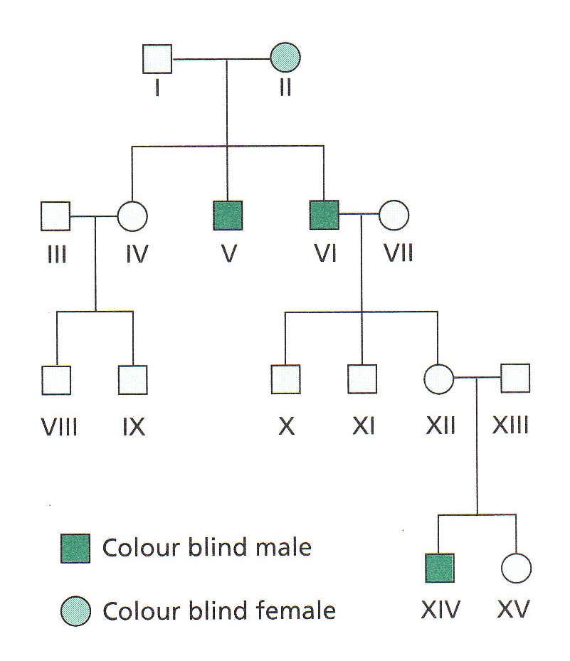

I II III

VI VII XII

XIII XIV

(4 marks)

1. If couple XII and XIII have another child, what is the probability that it will be a colour blind son? (Show all working)

(4 marks)

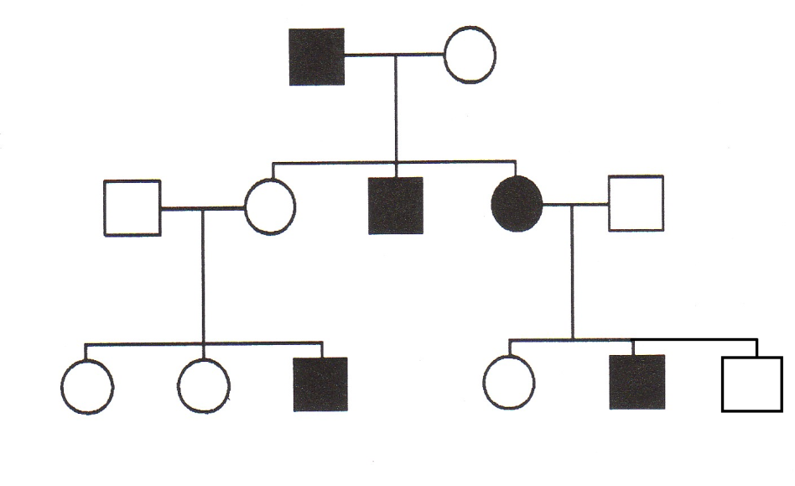

6

5

4

3

2

1

5

4

3

2

1

2

1

III

II

I

1. What type of inheritance is shown in the family tree above?

(1 mark)

1. What evidence do you have for this conclusion in a?

(2 marks)

1. If II 1 and II 2 had another child, what is the probability that the child would have the disorder? (Show all working)

(4 marks)

1. The pedigree diagram below shows the incidence of Dwarfism in one family. Use the pedigree diagram to answer the following questions.

1 2

1 2 3 4 5 6

1 2 3 4 5 6

**I**

**II**

**III**

Affected for Dwarfism

Unaffected for Dwarfism

* 1. Is Dwarfism a dominant or recessive condition?

(1 mark)

* 1. Give reasons for your answer in a.

(2 marks)

* 1. Is Dwarfism an Autosomal or sex-linked condition?

(1 mark)

* 1. Give reasons for your answer in c.

(2 marks)

* 1. Choose appropriate letters and state the genotypes of the following people:

I 1 I 2 II 1

II 2 II 4 II 5

III 1 III 6

(4 marks)

* 1. Why can’t we be sure of II 3’s genotype?

(1 mark)

* 1. What are the possible genotypes for person II 3?

(1 mark)

* 1. If II 5 and II 6 have another child, what is the probability that this child will have Dwarfism? (show all working)

(3 marks)

***END OF TEST***

***TOTAL MARKS: 30***